Assignment – 1

Abishek.P

1st year AI&DS

1. Write an algorithm, flowchart and pseudocode to find area of a rectangle.

Algorithm:

Step 1: Start

Step 2: get l,b values

Step 3: Calculate A=l\*b

Step 4: Display A

Step 5: Stop

Flowchart:

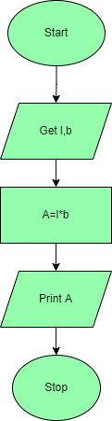

Pseudocode:

Begin

Read l, b

Calculate A=l\*b

Display A

End

1. Write an algorithm, flowchart and pseudocode for calculating area and circumference of circle.

Algorithm:

Step 1: Start

Step 2: get r value

Step 3: Calculate A=3.14\*r\*r

Step 4: Calculate C=2\*3.14\*r

Step 5: Display A, C

Step 6: Stop

Flowchart:

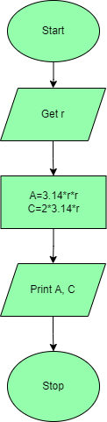

Pseudocode:

Begin

Read r

Calculate A and C

A=3.14\*r\*r

C=2\*3.14\*r

Display A

End

1. Write an algorithm flowchart and pseudocode for Calculating simple interest.

Algorithm:

Step 1: Start

Step 2: get p, n, r value

Step3: Calculate SI=(p\*n\*r)/100

Step 4: Display S

Step 5: Stop

Flowchart:

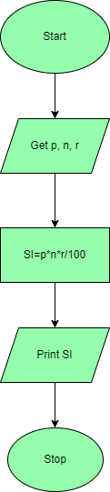

Pseudocode:

Begin

Read p, n, r

Calculate S

SI=(p\*n\*r)/100

Display SI

End

4.  Write an algorithm, flowchart and pseudocode for calculating engineering cut-off.

Algorithm:

Step 1: Start

Step2: get P, C, M value

Step3: calculate Cut-off= (P/4+C/4+M/2)

Step 4: Display Cut-off

Step 5: Stop

Flowchart:

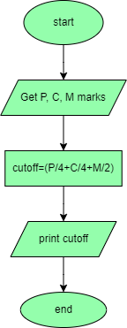

Pseudocode:

Begin

Read P, C, M

Calculate

Cut-off= (P/4+C/4+M/2)

Display Cut-off

End

5. Write an algorithm, flowchart and pseudocode for to check greatest of two numbers.

Algorithm:

Step 1: Start

Step 2: get a,b value

Step 3: check if(a>b) print a is greater

Step 4: else b is greater

Step 5: Stop

Flowchart:

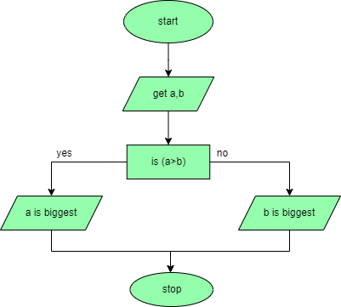

Pseudocode:

Begin

Read a, b

IF (a>b) Then

Display a is greater

Else

Display b is greater

End if

End

6. Write an algorithm, flowchart and pseudocode for to check positive or negative number.

Algorithm:

Step 1: Start

Step 2: get num

Step 3: check if(num>0) print a is positive

Step 4: else num is negative

Step 5: Stop

Flowchart:

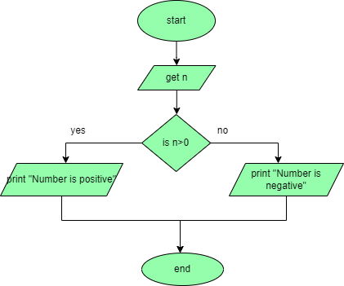

Pseudocode:

Begin

Read num

If (num>0) Then

Display num is positive

Else

Display num is negative

End If

End

7. Write an algorithm, flowchart and pseudocode for to check odd or even number.

Algorithm:

Step 1: Start

Step 2: get num

Step 3: check if(num%2==0) print num is even

Step 4: else num is odd

Step 5: Stop

Flowchart:

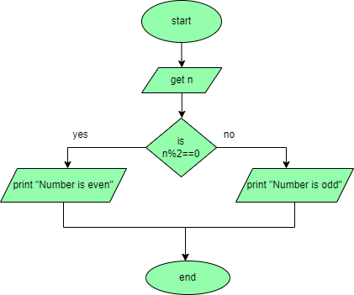

Pseudocode:

Begin

Read num

IF (num%2==0) THEN

Display num is even

Else

Display num is odd

End

8. Write an algorithm, flowchart and pseudocode to check greatest of three numbers.

Algorithm:

Step1: Start

Step2: Get A, B, C

Step3: if(A>B) goto Step4 else go to step5

Step4: If(A>C) print A else print C

Step5: If(B>C) print B else print C

Step6: Stop

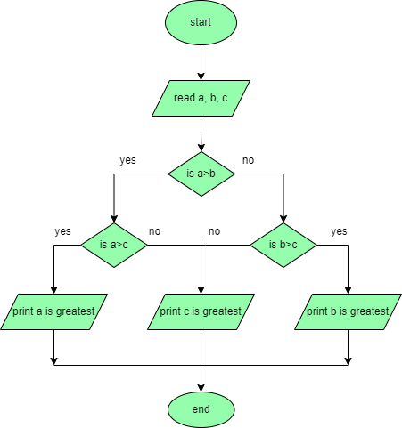

Pseudocode:

Begin

Read a, b, c

If (a>b) then

If (a>c) then

Display a is greater

Else

Display c is greater

End If

Else

If (b>c) then

Display b is greater

Else

Display c is greater

End if

End

9. Write an algorithm, flowchart and pseudocode to check whether given number is +ve, -ve or zero.

Algorithm:

Step 1: Start

Step 2: Get n value.

Step 3: if (n ==0) print “Given number is Zero” Else go to step4

Step 4: if (n > 0) then Print “Given number is +ve”

Step 5: else Print “Given number is -ve”

Step 6: Stop

Flowchart:

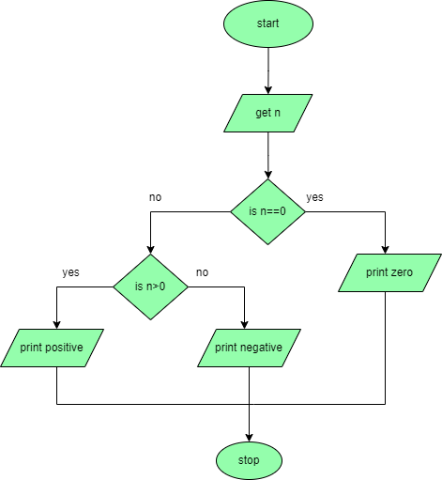

Pseudocode:

Begin

Get n

If(n==0) then

           Display “n is zero”

Else

           If(n>0) then

           Display “n is positive”

Else

            Display “n is negative”

End

10. Write an algorithm, flowchart and pseudocode to print all-natural numbers up to n.

Algorithm:

Step 1: Start

Step 2: get n value.

Step 3: initialize i=1

Step 4: if (i<=n) go to step 5 else go to step 8

Step 5: Print i value

step 6: increment i value by 1

Step 7: go to step 4

Step 8: Stop

Flowchart:

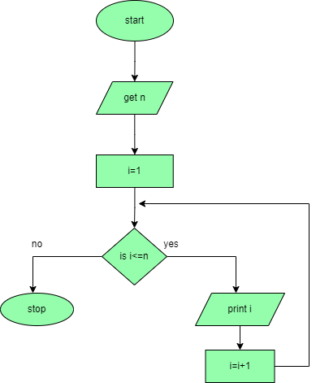

Pseudocode:

Begin

Get n

Initialize i=1

While (i<=n) Do

Print i

i=i+1

Endwhile

End

11.Write an algorithm, flowchart and pseudocode to print n odd numbers.

Algorithm:

Step 1: start

Step 2: get n value

Step 3: set initial value i=1

Step 4: check if(i<=n) go to step 5 else go to step 8

Step 5: print i value

Step 6: increment i value by 2

Step 7: go to step 4

Step 8: stop

Flowchart:

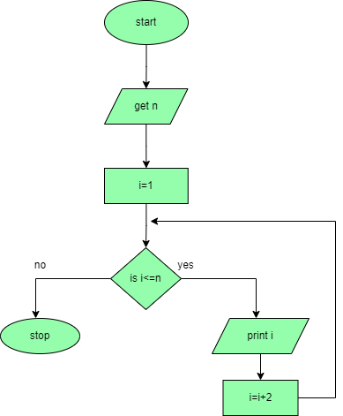

Pseudocode:

Begin

Get n

Initialize i=1

While (i<=n) DO

           Print i

           i=i+2

Endwhile

End

12.Write an algorithm, flowchart and pseudocode to print n even numbers.

Algorithm:

Step 1: start

Step 2: get n value

Step 3: set initial value i=2

Step 4: check if(i<=n) go to step 5 else go to step8

Step 5: print i value

Step6: increment i value by 2

Step 7: go to step 4

Step 8: stop

Flowchart:

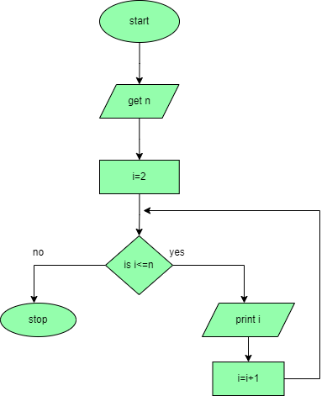

Pseudocode:

Begin

Get n

Initialize i=2

While (i<=n) DO

           Print i

           i=i+2

Endwhile

End

13.Write an algorithm, flowchart and pseudocode to print squares of a number.

Algorithm:

Step 1: start

Step 2: get n value

Step 3: set initial value i=1

Step 4: check i value if(i<=n) go to step 5 else go to step8

Step 5: print i\*i value

Step 6: increment i value by 1

Step 7: go to step 4

Step 8: stop

Flowchart: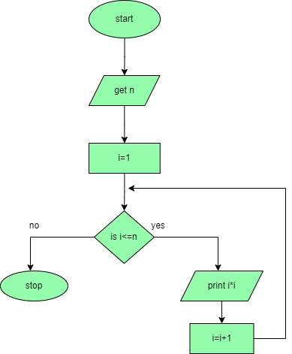

Pseudocode:

Begin

Get n

Initialize i=1

While (i<=n) DO

           Print i\*i

           i=i+2

Endwhile

End

14.Write an algorithm, flowchart and pseudocode to print to print cubes of a number.

Algorithm:

Step 1: start

Step 2: get n value

Step 3: set initial value i=1

Step 4: check i value if(i<=n) go to step 5 else go to step8

Step 5: print i\*i \*i value

Step 6: increment i value by 1

Step 7: go to step 4

Step 8: stop

Flowchart:

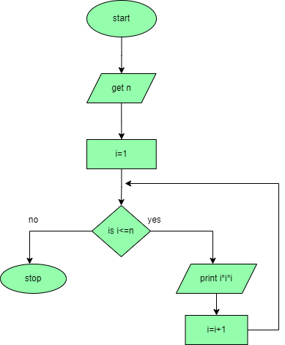

Pseudocode:

Begin

Get n

Initialize i=1

While (i<=n) DO

           Print i\*i\*i

           i=i+2

Endwhile

End

15.Write an algorithm, flowchart and pseudocode to find sum of a given number.

Algorithm:

Step 1: start

Step 2: get n value

Step 3: set initial value i=1, sum=0

Step 4: check i value if(i<=n) go to step 5 else go to step8

Step 5: calculate sum=sum+i

Step 6: increment i value by 1

Step 7:go to step 4

Step 8: print sum value

Step 9: stop

Flowchart:

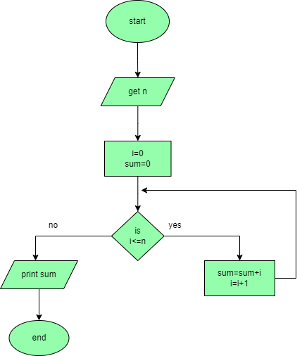

Pseudocode:

Begin

Get n

Initialize i=1, sum=0

While (i<=n) DO

           sum=sum+i

           i=i+1

Endwhile

Print sum

End

16.Write an algorithm,flowchart and pseudocode to find factorial of a given number.

Algorithm:

Step 1: start

step 2: get n value

step 3: set initial value i=1, fact=1

Step 4: check i value if(i<=n) goto step 5 else go to step8

step 5: calculate fact=fact\*i

step 6: increment i value by 1

step 7: go to step 4

step 8: print fact value

step 9: stop

Flowchart:

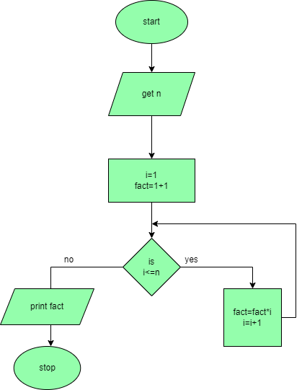

Pseudocode:

Begin

Get n

Initialize i=1, fact=1

While (i<=n) DO

           fact=fact\*i

           i=i+1

Endwhile

Print fact

End